**Learning Management System Website**

Emphasizing both nutrition and the shopping aspect

**A PROJECT REPORT**

***Submitted by***

*Aavni Shukla*

***Class Assessment 3 (CA3)***

***Of***

*K24RP*

**Semester-1**

**IN**

***B.TECH CSE***



**Lovely Professional University, Punjab**

**ENROLLMENT NUMBER: 1241361**

**Section: K24RP Roll No.: K24RP36 Date: 25/10/2025**

**Table of Contents**

**Chapter Particulars Page No.**

**Chapter 1. Introduction 3**

**Chapter 2. Technologies used 4-12**

**Chapter 3. Work Flow Diagram……… 13-14**

**Chapter 4. Working of Project………………… 15-17**

**Chapter 5. Snippets of Written Code…………… 18-20**

**Chapter 6. References………………… 21­­­**

**Chapter 1:- Introduction**

A website is a collection of related web pages that are typically accessible from a common domain name on the internet. It can contain various types of content, such as text, images, videos, and interactive elements, all of which are accessible via a web browser. Websites are created and maintained to provide information, services, or entertainment to users on the internet. They can serve a wide range of purposes, including sharing information, conducting business, providing online services, or facilitating communication.

The report focuses on the various responsibilities undertaken, including website maintenance, content management, security enhancement, and user support. It highlights the significance of effective communication, problem-solving skills, and technical proficiency in ensuring the smooth operation of the company's online presence.

“LMS(Learning Management System)” on Bootstrap is a web-based application that uses the Bootstrap framework for its user interface. Bootstrap ensures a responsive and visually appealing design across various devices. This system typically includes modules for student and teacher management, course administration, attendance tracking, grading, communication, and more. With its user-friendly interface and mobile responsiveness, a Bootstrap-based School Management System streamlines administrative tasks, enhances communication, and facilitates efficient management of academic and operational processes within educational institutions.

**Chapter 2:- Technologies Used**

* **HTML5**
* HTML stands for Hyper Text Markup Language.
* HTML is the Standard Markup Language for creating Web pages
* HTML describes the structure of a Web page
* HTML consists of a series of elements
* HTML elements tell the browser how to display the content
* HTML elements label pieces of content such as "this is a heading",

"this is a paragraph", "this is a link", etc.

* The latest version of HTML is HTML5.

**The History of HTML**

HTML was first created by Tim Berners-Lee, Robert Cailliau, and others starting in 1989. It stands for Hyper Text Markup Language.

Hypertext means that the document contains links that allow the reader to jump to other places in the document or to another document altogether. The latest version is known as HTML5.

A Markup Language is a way that computers speak to each other to control how text is processed and presented. To do this HTML uses two things: tags and attributes.

**Golden Rules To Remember:**

1. The vast majority of tags must be **opened** (<tag>) and **closed** (</tag>) with the element information such as a title or text resting between the tags.
2. When using multiple tags, the tags must be closed in the order in which they were opened.

For example :  
<strong><em>This is really important!</em></strong>

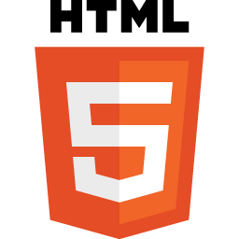

* **CSS3**
* CSS stands for Cascading Style Sheets.
* CSS describes how HTML elements are to be displayed on screen, paper, or in other media.
* CSS saves a lot of work. It can control the layout of multiple web pages all at once.
* External stylesheets are stored in CSS files.



**Syntax of CSS3 :-**

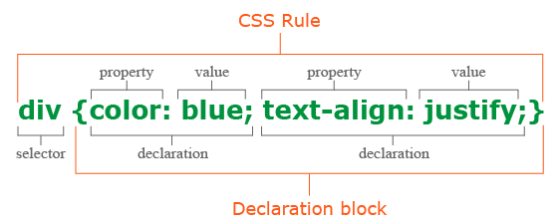

The selector points to the HTML element you want to style.

The declaration block contains one or more declarations separated by semicolons.

Each declaration includes a CSS property name and a value, separated by a colon.

Multiple CSS declarations are separated with semicolons, and declaration blocks

are surrounded by curly braces.

**Type of CSS3 :-**

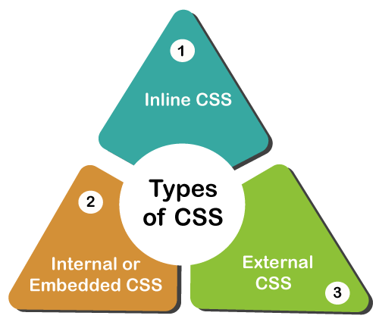

* **Inline CSS**: Inline CSS contains the [CSS](https://www.geeksforgeeks.org/css/) property in the body section attached to the element is known as inline CSS. This kind of style is specified within an HTML tag using the style attribute.
* **Internal or Embedded CSS**:This can be used when a single HTML document must be styled uniquely. The [CSS](https://www.geeksforgeeks.org/css/) rule set should be within the [HTML](https://www.geeksforgeeks.org/html/) file in the head section i.e. the [CSS](https://www.geeksforgeeks.org/css/) is embedded within the <style> tag inside the head section of the [HTML](https://www.geeksforgeeks.org/html/) file.
* **External CSS:** External CSS contains separate [CSS](https://www.geeksforgeeks.org/css/) files that contain only style properties with the help of tag attributes (For example class, id, heading, … etc). [CSS](https://www.geeksforgeeks.org/css/) property is written in a separate file with a .css extension and should be linked to the [HTML](https://www.geeksforgeeks.org/html/) document using a link tag. It means that, for each element, style can be set only once and will be applied across web pages.

**Type of Selectors in CSS3 :-**

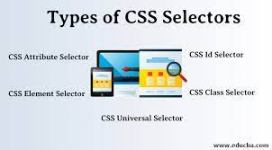

## The CSS element Selector:

## The element selector selects HTML elements based on the element name.

## The CSS id Selector:

## The id selector uses the id attribute of an HTML element to select a specific element. The id of an element is unique within a page, so the id selector is used to select one unique element! To select an element with a specific id, write a hash (#) character, followed by the id of the element.

## The CSS class Selector:

The class selector selects HTML elements with a specific class attribute. To select elements with a specific class, write a period (.) character, followed by the class name.

## The CSS Universal Selector:

The universal selector (*) selects all HTML elements on the page.

## The CSS Grouping Selector:

The grouping selector selects all the HTML elements with the same style definitions.

**Advantages of CSS3 :-**

* CSS plays an important role, by using CSS you simply got to specify a repeated style for element once & use it multiple times as because CSS will automatically apply the required styles.
* The main advantage of CSS is that style is applied consistently across variety of sites. One instruction can control several areas which is advantageous.
* Web designers needs to use few lines of programming for every page improving site speed.
* Cascading sheet not only simplifies website development, but also simplifies the maintenance as a change of one line of code affects the whole web site and maintenance time.
* It is less complex therefore the effort are significantly reduced.

**Disadvantages of CSS3 :-**

* CSS, CSS 1 up to CSS3, result in creating of confusion among  web browsers.
* With CSS, what works with one browser might not always work with another. The web developers need to test for compatibility, running the program across multiple browsers.
* There exists a scarcity of security.
* After making the changes we need to confirm the compatibility if they appear. The similar change affects on all the browsers.
* The programming language world is complicated for non-developers and beginners. Different levels of CSS i.e. CSS, CSS 2, CSS 3 are often quite confusing.
* **JavaScript**

JavaScript is *an object-based scripting language* which is lightweight and cross-platform.

JavaScript is not a compiled language, but it is a translated language. The JavaScript Translator (embedded in the browser) is responsible for translating the JavaScript code for the web browser.

JavaScript (js) is a light-weight object-oriented programming language which is used by several websites for scripting the webpages. It is an interpreted, full-fledged programming language that enables dynamic interactivity on websites when applied to an HTML document. It was introduced in the year 1995 for adding programs to the webpages in the Netscape Navigator browser. Since then, it has been adopted by all other graphical web browsers. With JavaScript, users can build modern web applications to interact directly without reloading the page every time. The traditional website uses js to provide several forms of interactivity and simplicity.



**Syntax of JavaScript :-**

JavaScript can be implemented using JavaScript statements that are placed within the **<script>... </script>** HTML tags in a web page.

You can place the **<script>** tags, containing your JavaScript, anywhere within your web page, but it is normally recommended that you should keep it within the **<head>** tags.

The <script> tag alerts the browser program to start interpreting all the text between these tags as a script. A simple syntax of your JavaScript will appear as follows.

<script ...>

JavaScript code

</script>

**Event of JavaScript :-**

The change in the state of an object is known as an **Event**. In html, there are various events which represents that some activity is performed by the user or by the browser. When [javascript](https://www.javatpoint.com/javascript-tutorial) code is included in [HTML](https://www.javatpoint.com/html-tutorial), js react over these events and allow the execution. This process of reacting over the events is called **Event Handling**. Thus, js handles the HTML events via **Event Handlers**.

## JavaScript Event Handlers

Event handlers can be used to handle and verify user input, user actions, and browser actions:

* Things that should be done every time a page loads
* Things that should be done when the page is closed
* Action that should be performed when a user clicks a button
* Content that should be verified when a user inputs data
* And more ...

Many different methods can be used to let JavaScript work with events:

* HTML event attributes can execute JavaScript code directly
* HTML event attributes can call JavaScript functions
* You can assign your own event handler functions to HTML elements
* You can prevent events from being sent or being handled

## Mouse events:

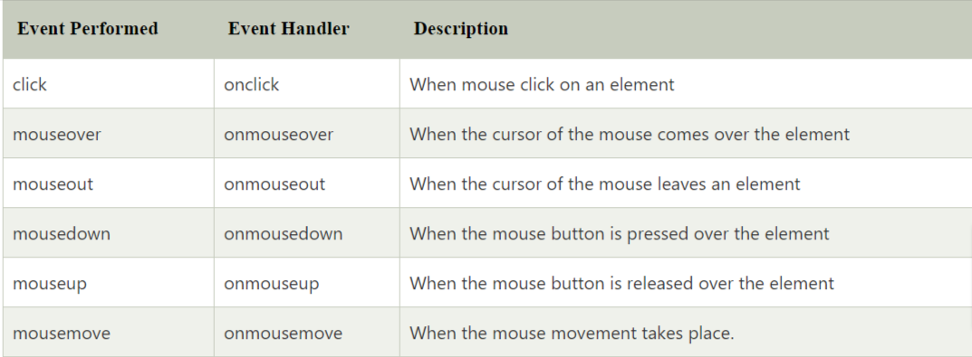

## Keyboard events:

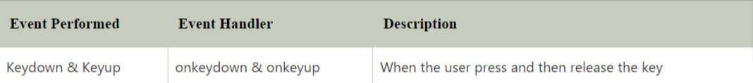

**Advantages of JavaScript:**

* Regardless of where you host JavaScript, it always gets executed on the client environment to save lots of bandwidth and make the execution process fast.
* JavaScript is employed everywhere on the web.
* JavaScript plays nicely with other languages and may be utilized in an enormous sort of applications.
* There are many open-source projects that provide useful help for developers to add JavaScript.
* There are many available courses within the field of JavaScript, because of which you’ll quickly and simply expand your knowledge of this programming language.

**Disadvantages of JavaScript:**

* This may be difficult to develop large applications, although you’ll also use the TypeScript overlay.
* The main problem or disadvantage in JavaScript is that the code is always visible to everyone anyone can view JavaScript code.
* No matter what proportion fast JavaScript interprets, JavaScript DOM (Document Object Model) is slow and can be a never-fast rendering with HTML.
* If the error occurs in JavaScript, it can stop rendering the whole website. Browsers are extremely tolerant of JavaScript errors.
* JavaScript is usually interpreted differently by different browsers. This makes it somewhat complex to read and write cross-browser code.
* **Visual Studio**

Visual Studio is an integrated development environment (IDE) from Microsoft. It is used to develop computer programs including websites, web apps, web services and mobile apps. Visual Studio uses Microsoft software development platforms such as Windows API, Windows Forms, Windows Presentation Foundation, Windows Store and Microsoft Silverlight. It can produce both native code and managed code.

Visual Studio includes a code editor supporting IntelliSense (the code completion component) as well as code refactoring. The integrated debugger works as both a source-level debugger and as a machine-level debugger. Other built-in tools include a code profiler, designer for building GUI applications, web designer, class designer, and database schema designer. It accepts plug-ins that expand the functionality at almost every level—including adding support for source control systems (like Subversion and Git) and adding new toolsets like editors and visual designers for domain-specific languages or toolsets for other aspects of the software development lifecycle (like the Azure DevOps client: Team Explorer).



**Chapter 3:- Work Flow Diagram**

**Chapter 4:- Working of Project**

***Home Page***

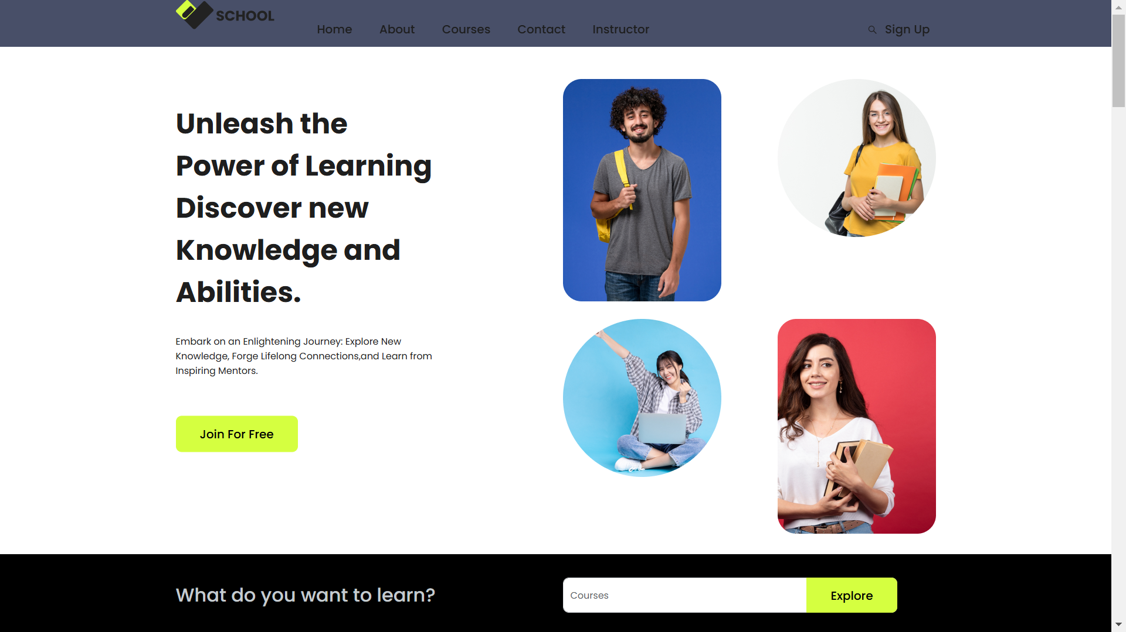

***Course Page***

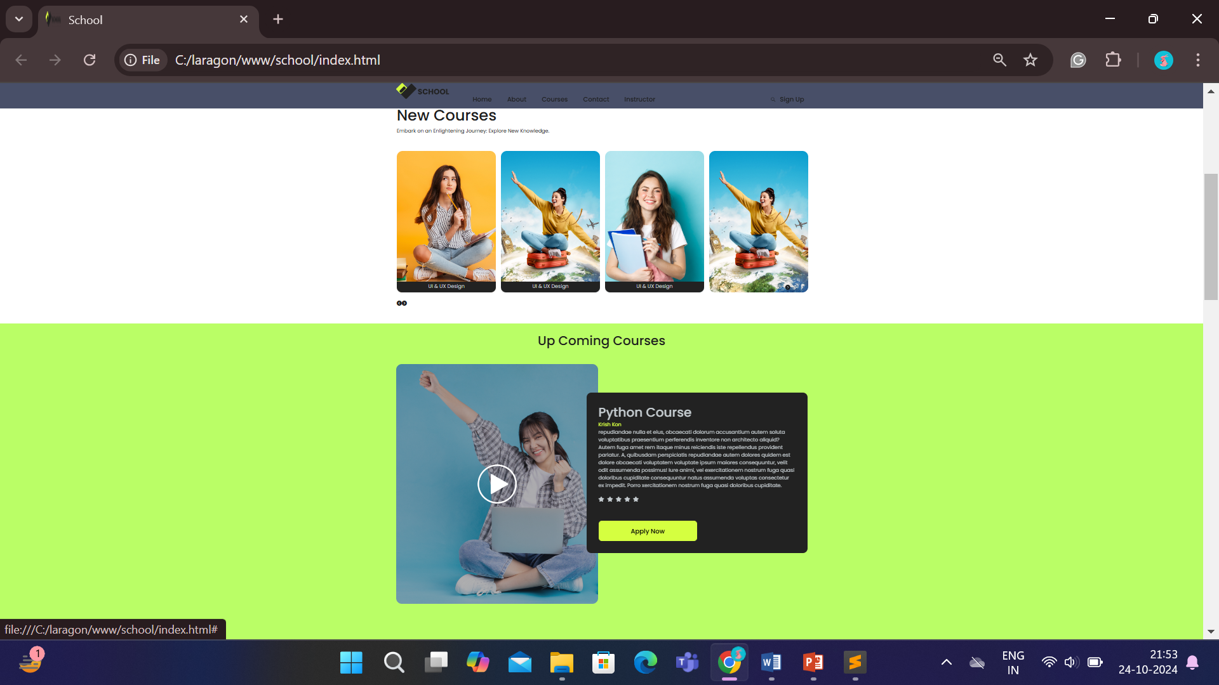

***About Page***



***Contact Page***

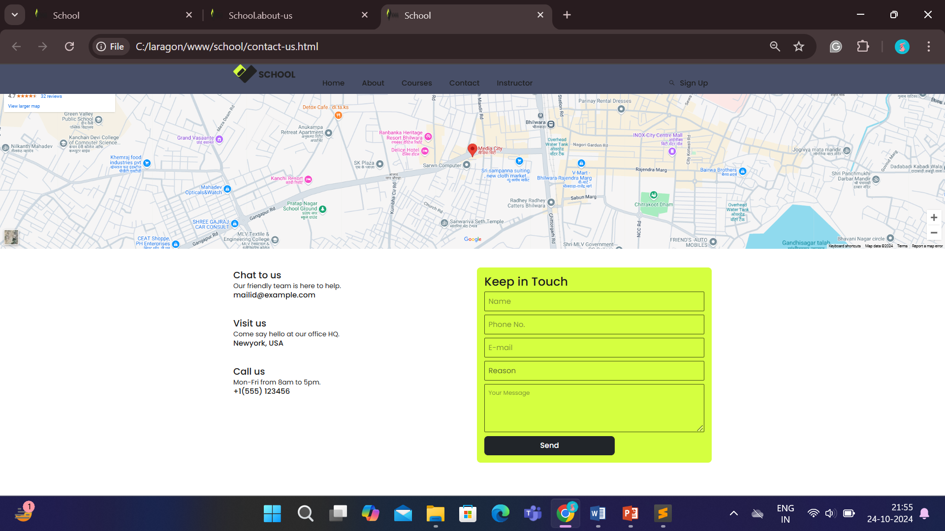

***Login Page***

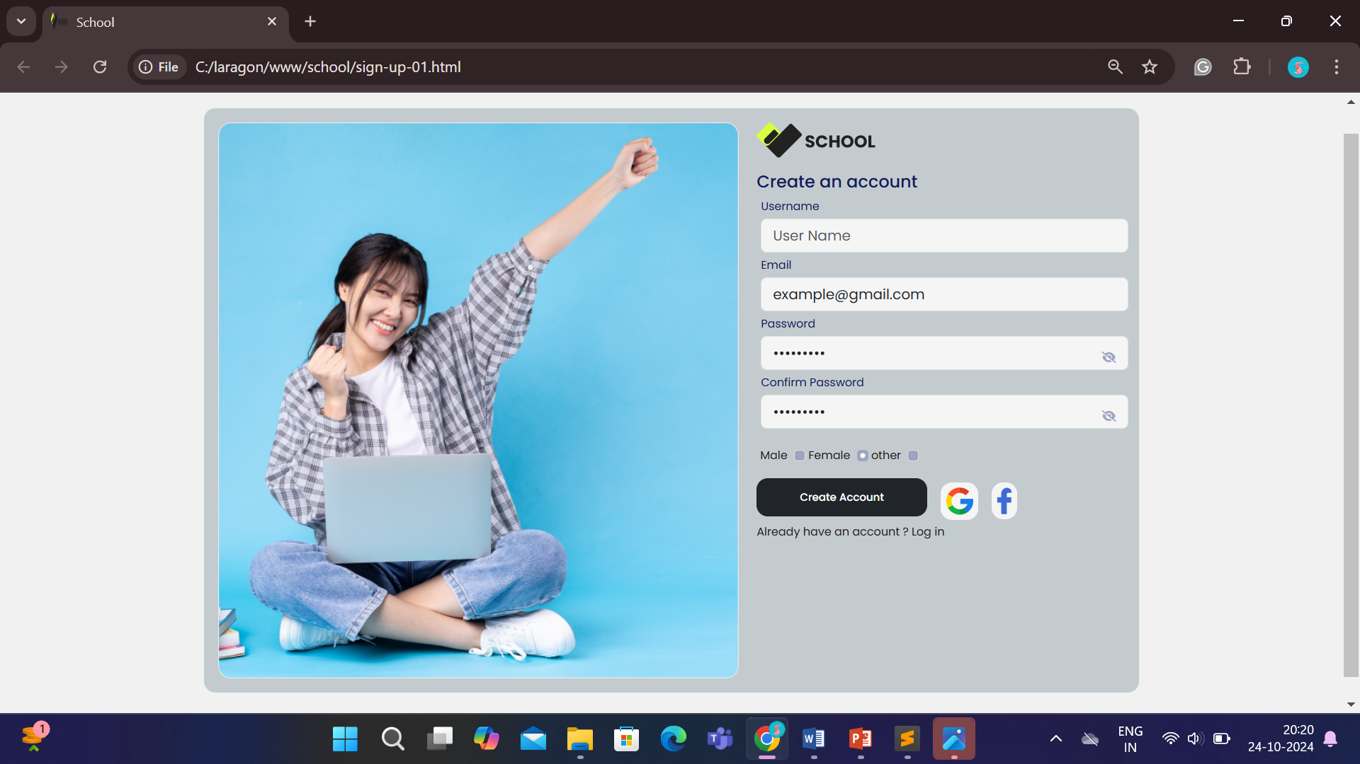

***Instructor Page***

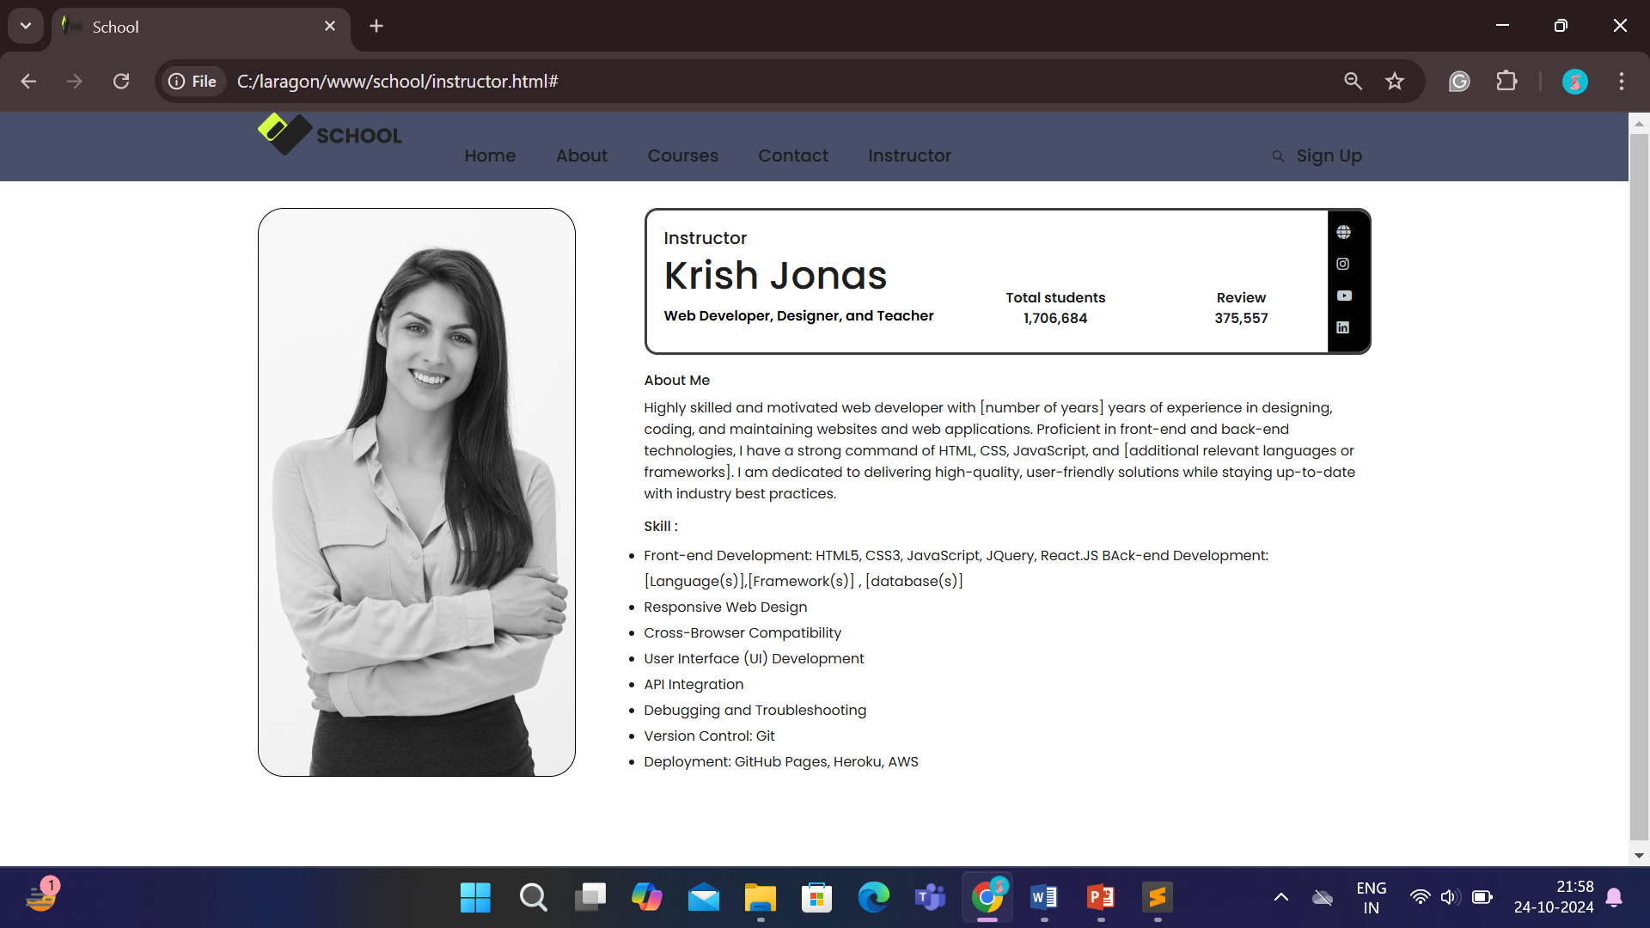

**Chapter6:- Snippets of Written Code**

***Header Code***

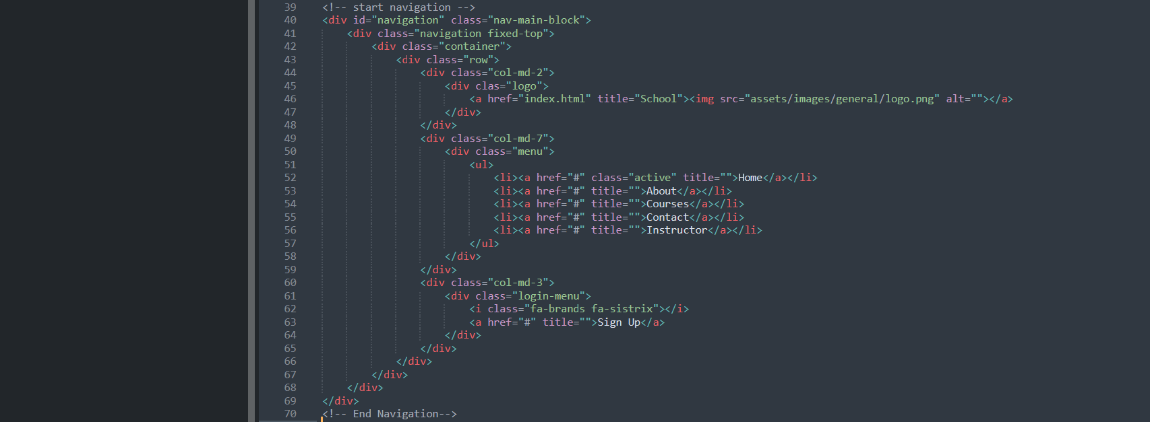

***Home Page Code***

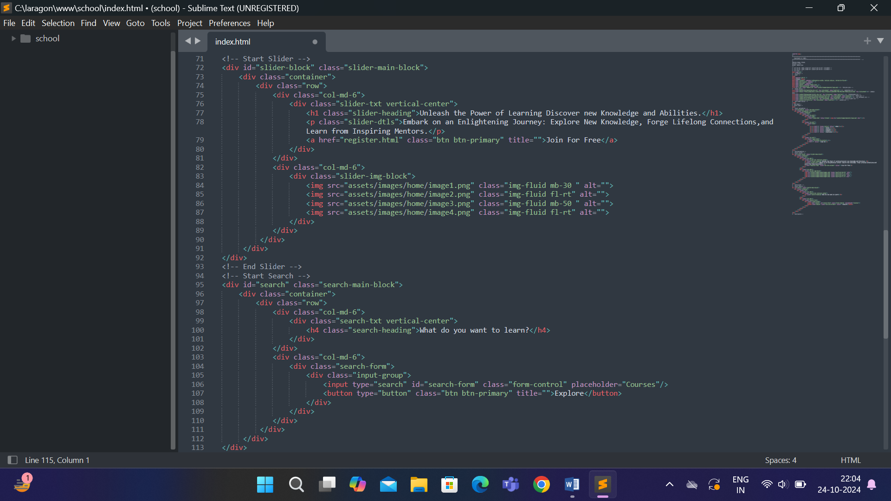

***About Page Code***

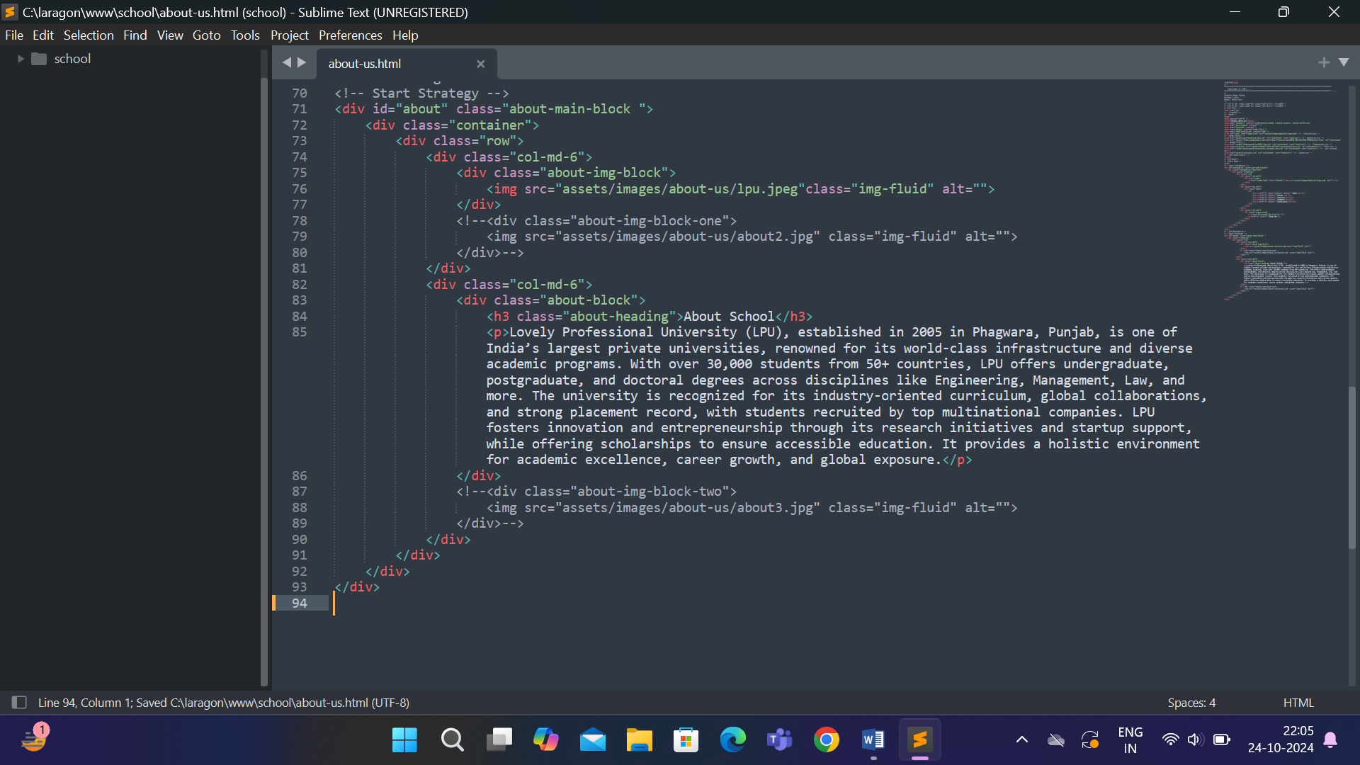

***Contact Page Code***

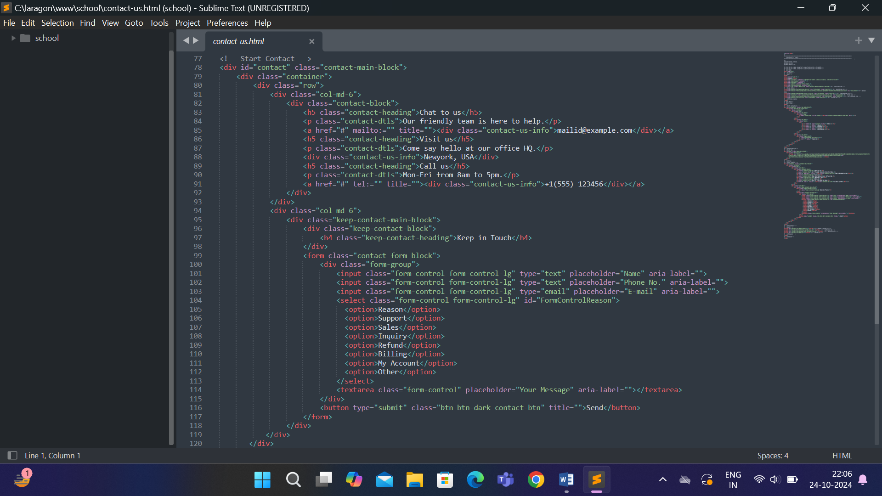

***Login Page Code***

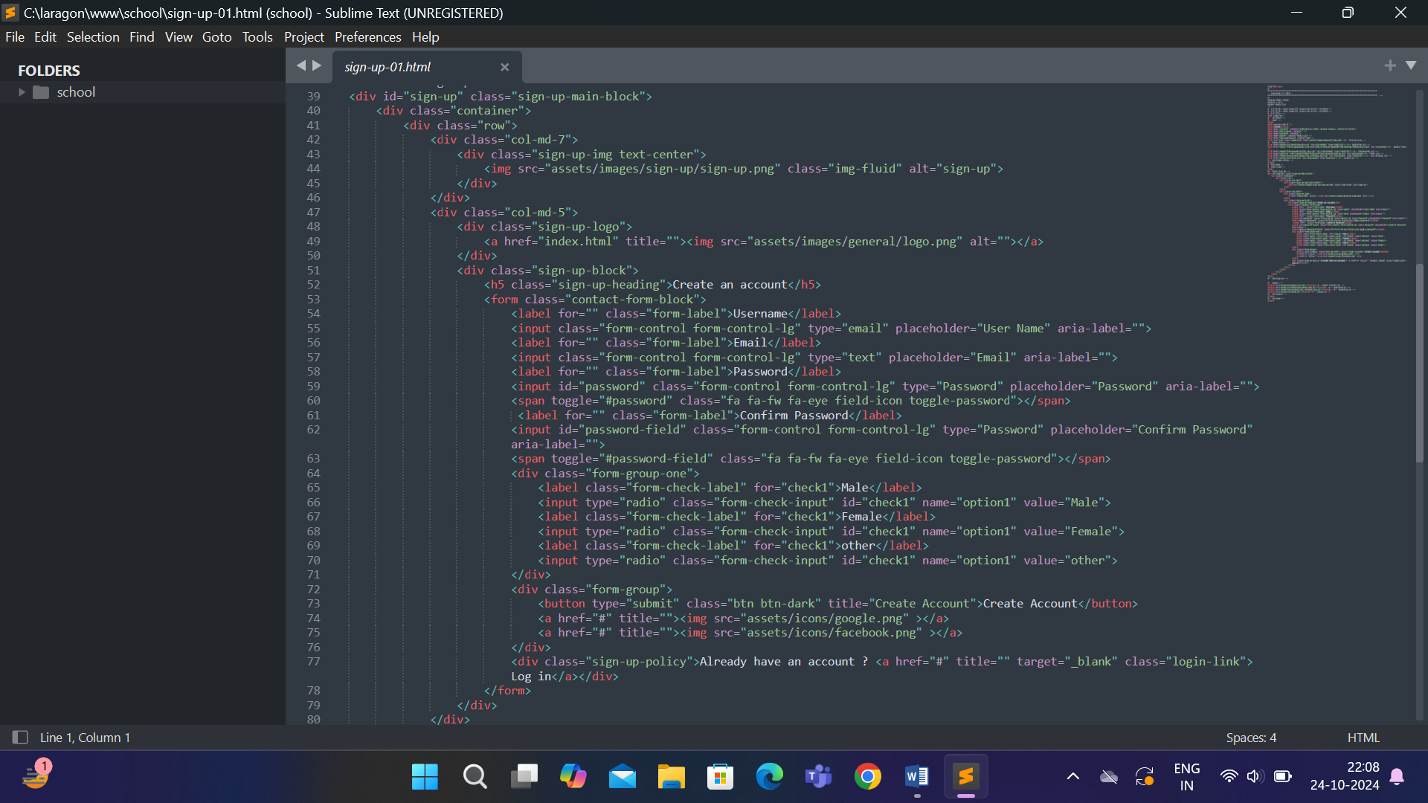

***Instructor Page Code***

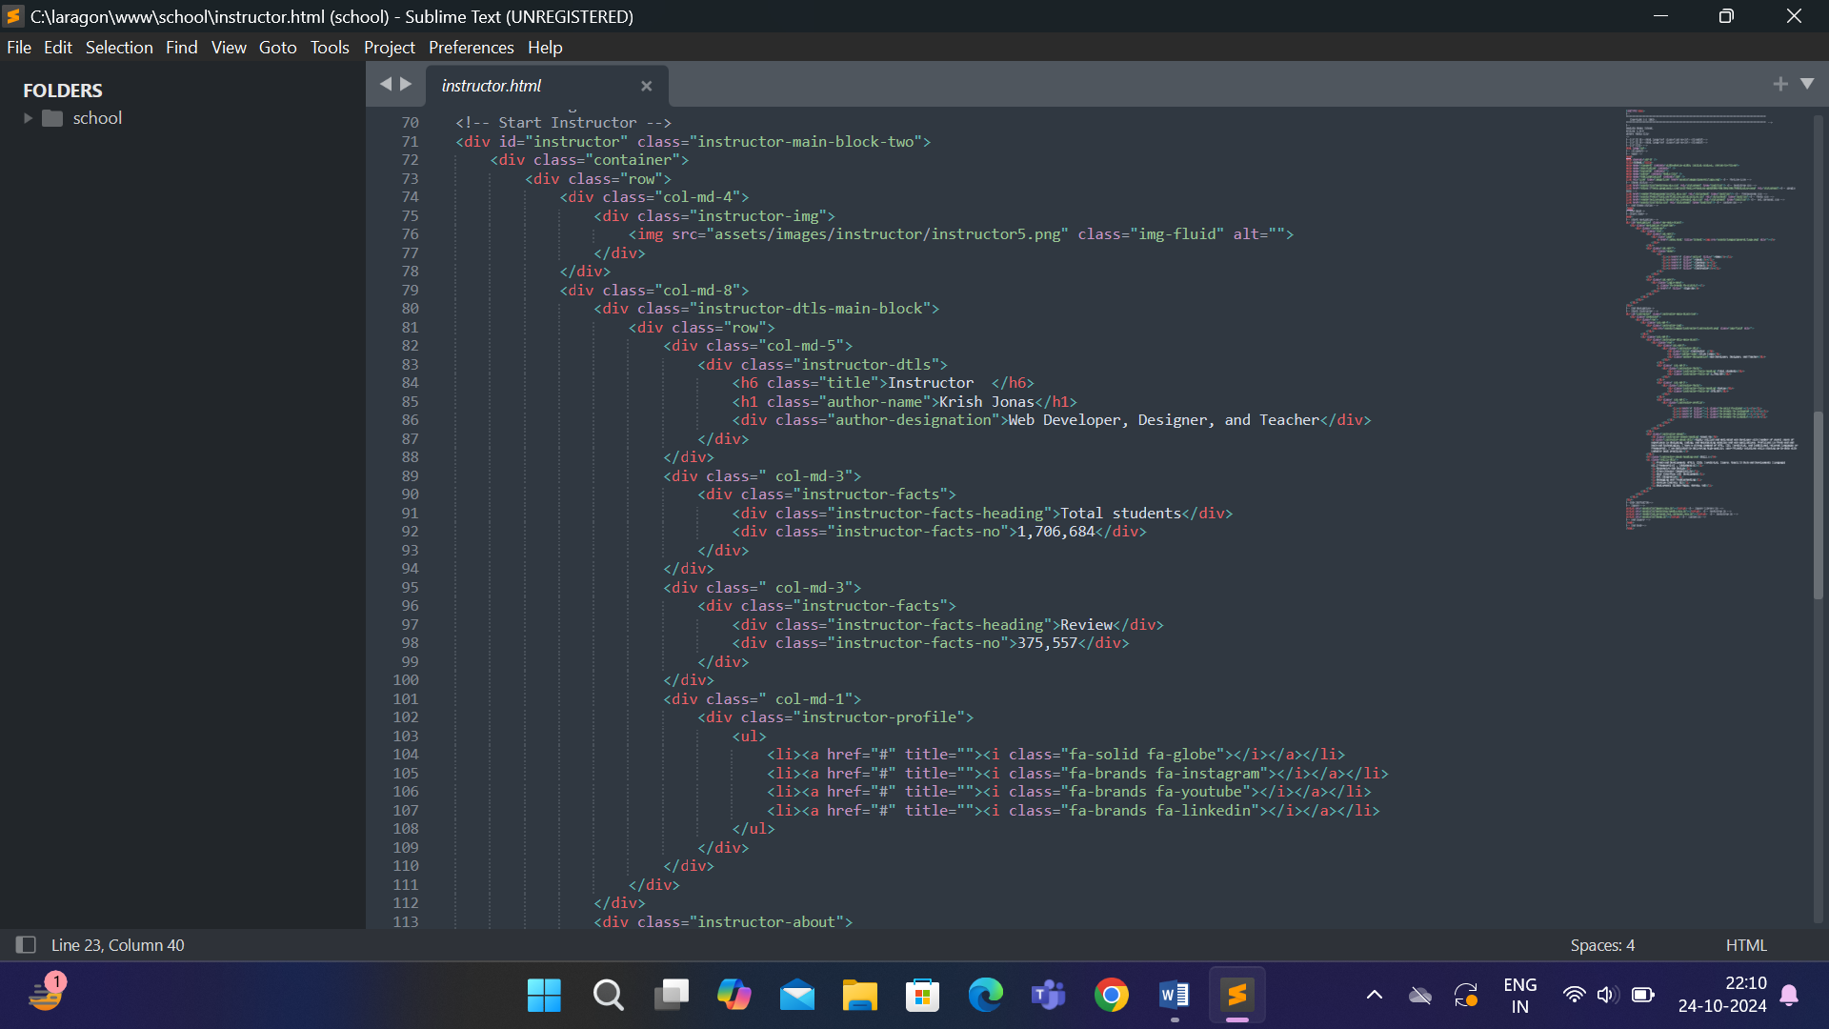

**Reference**

[1] **https://getbootstrap.com/**

[2] **https://owlcarousel2.github.io/OwlCarousel2/**

[3] **https://github.com/**

[4] **https://fontawesome.com/**

[5] **https://www.flaticon.com/**

[6] **https://wowjs.uk/**

[7] **https://freefrontend.com/css-hover-effects/**

[8] **https://freefrontend.com/css-button-hover-effects/**

[9] **https://codepen.io/**

[10] **https://fonts.google.com/**

**THANK YOU !!**